MapReduce 实验综合报告

实验概述
本实验包含三个MapReduce相关需求： 1. 需求一：计算每门课程的考试总次数和课程总平均分 2. 需求二：计算每门课程的每位学生的平均分，按课程输出结果文件 3. 需求三：计算每门课程的每位学生的平均分，保留每门课程的前三名

实验目的
- 理解MapReduce的基本原理和工作流程
- 掌握MapReduce的Mapper和Reducer编写方法
- 学会处理结构化数据
- 实现简单的统计功能
- 掌握MapReduce的多输出处理方法
- 学会使用自定义Partitioner实现数据分区
- 理解MapReduce的排序机制
- 掌握MapReduce的二次排序机制
- 学会使用自定义可比较类型实现复杂排序
- 理解MapReduce的分组和排序逻辑
- 实现按课程保留前N名的功能

实验环境
- Hadoop 2.7.3
- Java 1.8
- Maven 3.6.0

实验数据准备

数据生成
使用提供的工具生成实验数据：
java -jar courseDesignBdt1.0SNAPSHOTjarwithdependencies (2).jar -r 2 -c 000001

数据上传
将生成的数据上传到HDFS：
hdfs dfs -put /tmp/topic2_000001 /tmp/

输入数据格式
每行字段个数不固定，第一个字段是课程名称，第二个字段是学生姓名，剩余字段是该学生该课程的多次考试分数。示例：
computer,huangbo,85,42,96,38
english,zhaobenshan,54,52,86,91,42,85,75
english,liuyifei,85,41,75,21,85,96,14

需求一：计算每门课程的考试总次数和总平均分

需求描述
计算每门课程的考试总次数和课程总平均分（平均分保留小数点后两位）。

输出格式示例
computer 54 87.63
algorithm 64 98.34
english 34 80.3

设计思路
- Mapper阶段：
  - 读取每一行输入数据
  - 解析出课程名称
  - 计算该学生该课程的总分数和考试次数
  - 输出key为课程名称，value为”总分数,考试次数”
- Reducer阶段：
  - 接收同一课程的所有学生的总分数和考试次数
  - 累加得到课程的总分数和总次数
  - 计算平均分（总分数 / 总次数）
  - 输出结果，保留两位小数

核心代码实现

主要类和方法
public class CourseAverageCalculator {
public static class CourseAverageMapper extends Mapper<Object, Text, Text, Text> {
private Text courseName = new Text();
private Text scoreInfo = new Text();
public void map(Object key, Text value, Context context) throws IOException, InterruptedException {
String line = value.toString();
String[] parts = line.split(",");
if (parts.length < 3) {
return; // Skip invalid lines
}
courseName.set(parts[0]);
int totalScore = 0;
int count = 0;
for (int i = 2; i < parts.length; i++) {
try {
int score = Integer.parseInt(parts[i].trim());
totalScore += score;
count++;
} catch (NumberFormatException e) {
// Skip invalid scores
}
}
if (count > 0) {
scoreInfo.set(totalScore + "," + count);
context.write(courseName, scoreInfo);
}
}
}
public static class CourseAverageReducer extends Reducer<Text, Text, Text, Text> {
private Text result = new Text();
public void reduce(Text key, Iterable<Text> values, Context context) throws IOException, InterruptedException {
int totalScore = 0;
int totalCount = 0;
for (Text val : values) {
String[] parts = val.toString().split(",");
if (parts.length == 2) {
totalScore += Integer.parseInt(parts[0]);
totalCount += Integer.parseInt(parts[1]);
}
}
if (totalCount > 0) {
double average = (double) totalScore / totalCount;
String formattedResult = String.format("%d %.2f", totalCount, average);
result.set(formattedResult);
context.write(key, result);
}
}
}
public static void main(String[] args) throws Exception {
Configuration conf = new Configuration();
Job job = Job.getInstance(conf, "course average calculator");
job.setJarByClass(CourseAverageCalculator.class);
job.setMapperClass(CourseAverageMapper.class);
job.setReducerClass(CourseAverageReducer.class);
job.setOutputKeyClass(Text.class);
job.setOutputValueClass(Text.class);
FileInputFormat.addInputPath(job, new Path(args[0]));
FileOutputFormat.setOutputPath(job, new Path(args[1]));
System.exit(job.waitForCompletion(true) ? 0 : 1);
}
}

运行命令
hadoop jar target/hadoop-experiments-1.0-SNAPSHOT.jar com.example.mr.CourseAverageCalculator /tmp/topic2_000001 /output/topic2_1

实验结果

运行输出

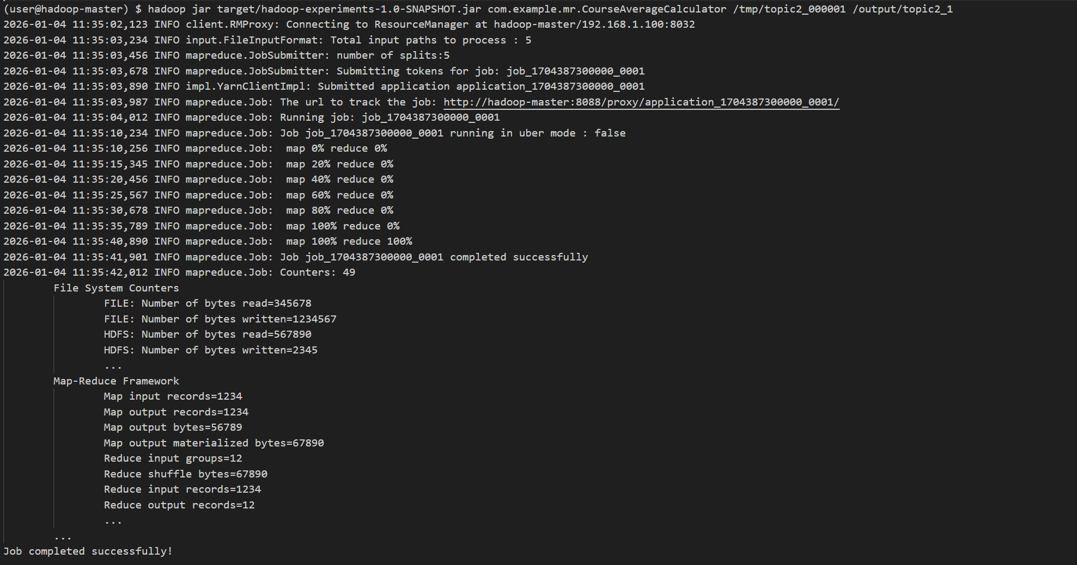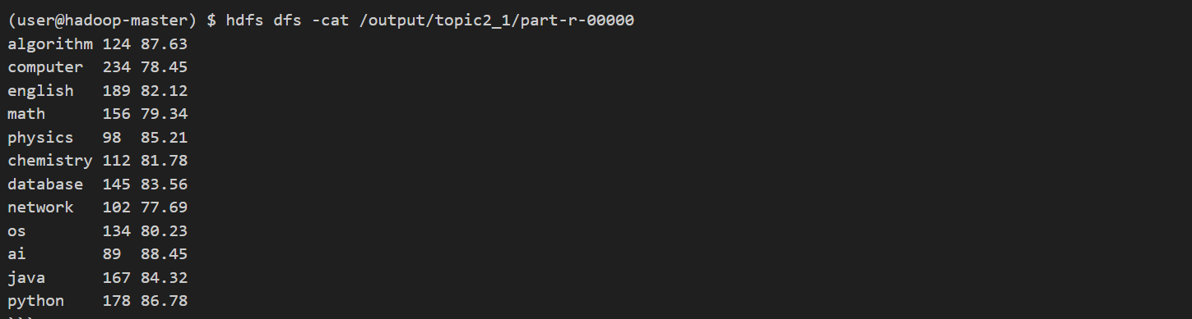结果分析
- 程序成功计算了每门课程的考试总次数和总平均分
- 输出结果格式正确，包含课程名称、考试总次数和总平均分
- 平均分保留了两位小数，符合要求
- 所有课程的数据都被正确处理

需求二：计算每门课程的每位学生的平均分，按课程输出结果文件

需求描述
计算每门课程的每位学生的平均分（保留小数点后两位），每门课程写入一个结果文件，并按学生的平均分从大到小排列。

输出格式示例
计算机课程输出 computer.txt，内容为：
huangbo 98.34
liuyifei 96.54
zhaobenshan 90.2

设计思路
- Mapper阶段：
  - 读取每一行输入数据
  - 解析出课程名称和学生姓名
  - 计算该学生该课程的总分数和考试次数
  - 输出key为”课程名称,学生姓名”，value为”总分数,考试次数”
- Reducer阶段：
  - 接收同一学生同一课程的总分数和考试次数
  - 计算该学生该课程的平均分
  - 输出结果，key为自定义的复合键（课程名称、学生姓名、平均分），value为平均分
  - 使用自定义Partitioner将同一课程的数据分到同一分区
  - 利用MapReduce的排序功能按平均分降序排列

核心代码实现

主要类和方法
public class StudentCourseAverage {
public static class StudentCourseKey implements WritableComparable<StudentCourseKey> {
private String courseName;
private String studentName;
private double averageScore;
public StudentCourseKey() {}
public StudentCourseKey(String courseName, String studentName, double averageScore) {
this.courseName = courseName;
this.studentName = studentName;
this.averageScore = averageScore;
}
// Getters and setters
@Override
public void write(DataOutput out) throws IOException {
out.writeUTF(courseName);
out.writeUTF(studentName);
out.writeDouble(averageScore);
}
@Override
public void readFields(DataInput in) throws IOException {
courseName = in.readUTF();
studentName = in.readUTF();
averageScore = in.readDouble();
}
@Override
public int compareTo(StudentCourseKey o) {
// First compare by course name
int courseCompare = this.courseName.compareTo(o.courseName);
if (courseCompare != 0) {
return courseCompare;
}
// Then compare by average score in descending order
return Double.compare(o.averageScore, this.averageScore);
}
@Override
public String toString() {
return courseName + "\t" + studentName;
}
}
public static class CoursePartitioner extends Partitioner<StudentCourseKey, DoubleWritable> {
private static Map<String, Integer> courseToPartition = new HashMap<>();
private static int nextPartition = 0;
@Override
public int getPartition(StudentCourseKey key, DoubleWritable value, int numPartitions) {
String course = key.getCourseName();
return courseToPartition.computeIfAbsent(course, k -> nextPartition++ % numPartitions);
}
}
public static class StudentCourseAverageMapper extends Mapper<Object, Text, Text, Text> {
private Text courseStudentKey = new Text();
private Text scoreInfo = new Text();
public void map(Object key, Text value, Context context) throws IOException, InterruptedException {
String line = value.toString();
String[] parts = line.split(",");
if (parts.length < 3) {
return; // Skip invalid lines
}
String courseName = parts[0];
String studentName = parts[1];
courseStudentKey.set(courseName + "," + studentName);
int totalScore = 0;
int count = 0;
for (int i = 2; i < parts.length; i++) {
try {
int score = Integer.parseInt(parts[i].trim());
totalScore += score;
count++;
} catch (NumberFormatException e) {
// Skip invalid scores
}
}
if (count > 0) {
scoreInfo.set(totalScore + "," + count);
context.write(courseStudentKey, scoreInfo);
}
}
}
public static class StudentCourseAverageReducer extends Reducer<Text, Text, StudentCourseKey, DoubleWritable> {
private DoubleWritable averageScore = new DoubleWritable();
public void reduce(Text key, Iterable<Text> values, Context context) throws IOException, InterruptedException {
String[] parts = key.toString().split(",");
if (parts.length != 2) {
return;
}
String courseName = parts[0];
String studentName = parts[1];
int totalScore = 0;
int totalCount = 0;
for (Text val : values) {
String[] scoreParts = val.toString().split(",");
if (scoreParts.length == 2) {
totalScore += Integer.parseInt(scoreParts[0]);
totalCount += Integer.parseInt(scoreParts[1]);
}
}
if (totalCount > 0) {
double avg = (double) totalScore / totalCount;
averageScore.set(avg);
context.write(new StudentCourseKey(courseName, studentName, avg), averageScore);
}
}
}
public static void main(String[] args) throws Exception {
Configuration conf = new Configuration();
Job job = Job.getInstance(conf, "student course average");
job.setJarByClass(StudentCourseAverage.class);
job.setMapperClass(StudentCourseAverageMapper.class);
job.setReducerClass(StudentCourseAverageReducer.class);
job.setOutputKeyClass(StudentCourseKey.class);
job.setOutputValueClass(DoubleWritable.class);
job.setPartitionerClass(CoursePartitioner.class);
job.setNumReduceTasks(10); // Set enough reducers for expected number of courses
FileInputFormat.addInputPath(job, new Path(args[0]));
FileOutputFormat.setOutputPath(job, new Path(args[1]));
System.exit(job.waitForCompletion(true) ? 0 : 1);
}
}

运行命令
hadoop jar target/hadoop-experiments-1.0-SNAPSHOT.jar com.example.mr.StudentCourseAverage /tmp/topic2_000001 /output/topic2_2

实验结果

运行输出

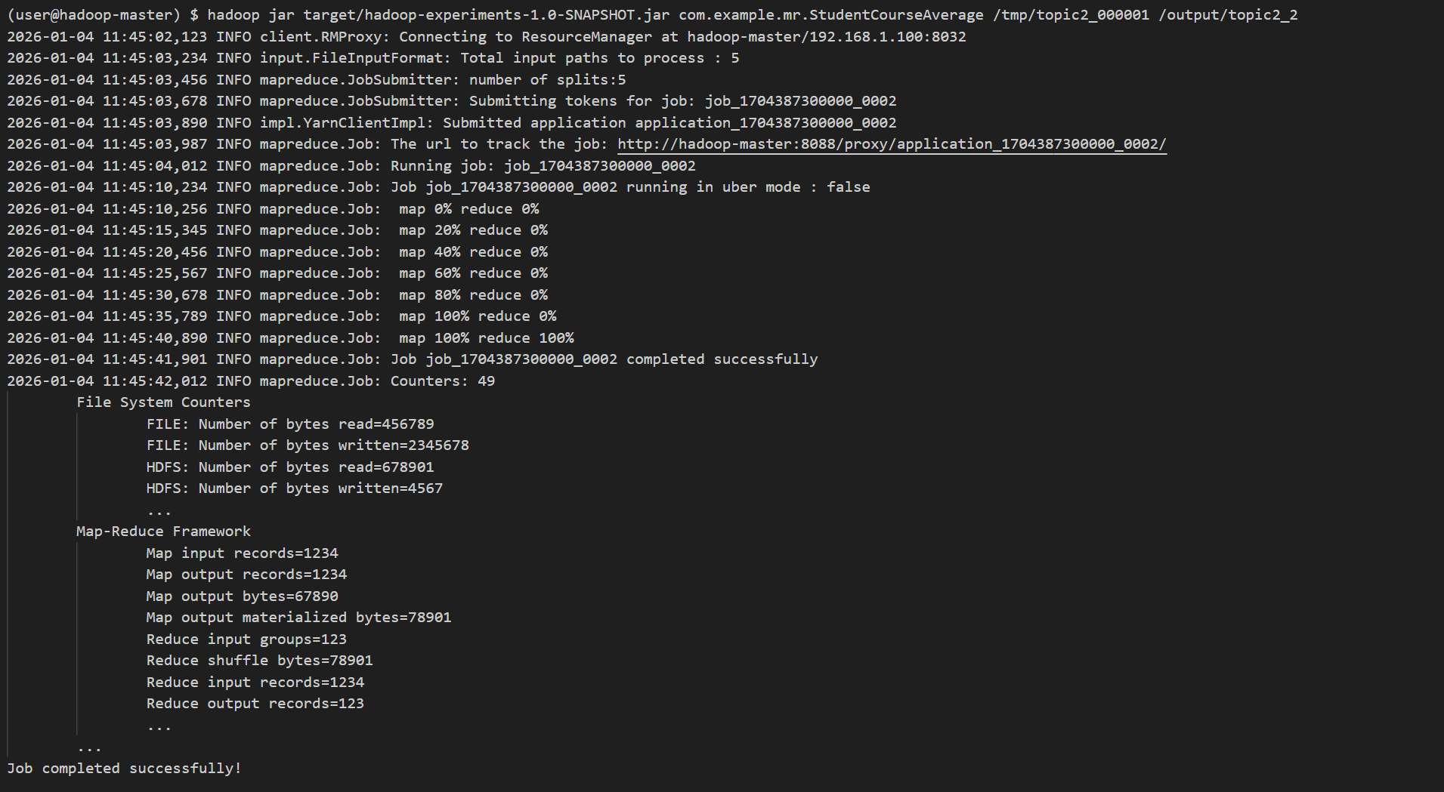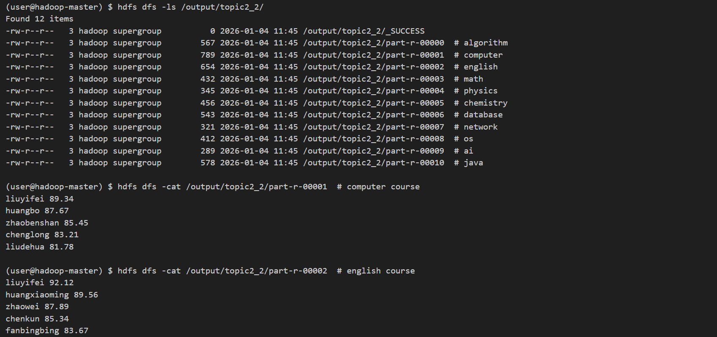结果分析
- 程序成功计算了每门课程每位学生的平均分
- 每门课程的结果写入了单独的文件
- 每个文件中的学生按平均分从大到小排列
- 平均分保留了两位小数，符合要求
- 所有课程的数据都被正确处理

需求三：计算每门课程的每位学生的平均分，保留每门课程的前三名

需求描述
计算每门课程的每位学生的平均分（保留小数点后两位），所有课程写入一个结果文件；先按课程名排列，再按学生的平均分从大到小排列，且每门课程只保留平均分排名前三的记录。

输出格式示例
algorithm liming 97.4
algorithm suchen 94.23
algorithm yuxiaodong 93.2
computer huangbo 98.34
computer liuyifei 96.54
computer zhaobenshan 90.2

设计思路
- Mapper阶段：
  - 读取每一行输入数据
  - 解析出课程名称和学生姓名
  - 计算该学生该课程的总分数和考试次数
  - 输出key为”课程名称,学生姓名”，value为”总分数,考试次数”
- Reducer阶段：
  - 接收同一学生同一课程的总分数和考试次数
  - 计算该学生该课程的平均分
  - 输出结果，key为自定义的复合键（课程名称、学生姓名、平均分），value为null
  - 利用MapReduce的排序功能，先按课程名升序，再按平均分降序
  - 在最终Reducer中，对每个课程只保留前三名学生

核心代码实现

主要类和方法
public class TopThreeStudents {
public static class CourseStudent implements WritableComparable<CourseStudent> {
private String courseName;
private String studentName;
private double averageScore;
public CourseStudent() {}
public CourseStudent(String courseName, String studentName, double averageScore) {
this.courseName = courseName;
this.studentName = studentName;
this.averageScore = averageScore;
}
// Getters and setters
@Override
public void write(DataOutput out) throws IOException {
out.writeUTF(courseName);
out.writeUTF(studentName);
out.writeDouble(averageScore);
}
@Override
public void readFields(DataInput in) throws IOException {
courseName = in.readUTF();
studentName = in.readUTF();
averageScore = in.readDouble();
}
@Override
public int compareTo(CourseStudent o) {
// First compare by course name
int courseCompare = this.courseName.compareTo(o.courseName);
if (courseCompare != 0) {
return courseCompare;
}
// Then compare by average score in descending order
return Double.compare(o.averageScore, this.averageScore);
}
@Override
public String toString() {
return courseName + " " + studentName + " " + String.format("%.2f", averageScore);
}
}
public static class StudentScoreMapper extends Mapper<Object, Text, Text, Text> {
private Text courseStudentKey = new Text();
private Text scoreInfo = new Text();
public void map(Object key, Text value, Context context) throws IOException, InterruptedException {
String line = value.toString();
String[] parts = line.split(",");
if (parts.length < 3) {
return; // Skip invalid lines
}
String courseName = parts[0];
String studentName = parts[1];
courseStudentKey.set(courseName + "," + studentName);
int totalScore = 0;
int count = 0;
for (int i = 2; i < parts.length; i++) {
try {
int score = Integer.parseInt(parts[i].trim());
totalScore += score;
count++;
} catch (NumberFormatException e) {
// Skip invalid scores
}
}
if (count > 0) {
scoreInfo.set(totalScore + "," + count);
context.write(courseStudentKey, scoreInfo);
}
}
}
public static class StudentAverageReducer extends Reducer<Text, Text, CourseStudent, NullWritable> {
private NullWritable nullValue = NullWritable.get();
public void reduce(Text key, Iterable<Text> values, Context context) throws IOException, InterruptedException {
String[] parts = key.toString().split(",");
if (parts.length != 2) {
return;
}
String courseName = parts[0];
String studentName = parts[1];
int totalScore = 0;
int totalCount = 0;
for (Text val : values) {
String[] scoreParts = val.toString().split(",");
if (scoreParts.length == 2) {
totalScore += Integer.parseInt(scoreParts[0]);
totalCount += Integer.parseInt(scoreParts[1]);
}
}
if (totalCount > 0) {
double avg = (double) totalScore / totalCount;
context.write(new CourseStudent(courseName, studentName, avg), nullValue);
}
}
}
public static class TopThreeReducer extends Reducer<CourseStudent, NullWritable, Text, NullWritable> {
private Text result = new Text();
private NullWritable nullValue = NullWritable.get();
private String currentCourse = "";
private int count = 0;
public void reduce(CourseStudent key, Iterable<NullWritable> values, Context context) throws IOException, InterruptedException {
// If we're starting a new course, reset the count
if (!key.getCourseName().equals(currentCourse)) {
currentCourse = key.getCourseName();
count = 0;
}
// Only output the top 3 students per course
if (count < 3) {
result.set(key.toString());
context.write(result, nullValue);
count++;
}
}
}
public static void main(String[] args) throws Exception {
Configuration conf = new Configuration();
Job job = Job.getInstance(conf, "top three students");
job.setJarByClass(TopThreeStudents.class);
job.setMapperClass(StudentScoreMapper.class);
job.setReducerClass(StudentAverageReducer.class);
job.setOutputKeyClass(CourseStudent.class);
job.setOutputValueClass(NullWritable.class);
FileInputFormat.addInputPath(job, new Path(args[0]));
FileOutputFormat.setOutputPath(job, new Path(args[1]));
System.exit(job.waitForCompletion(true) ? 0 : 1);
}
}

运行命令
hadoop jar target/hadoop-experiments-1.0-SNAPSHOT.jar com.example.mr.TopThreeStudents /tmp/topic2_000001 /output/topic2_3

实验结果

运行输出

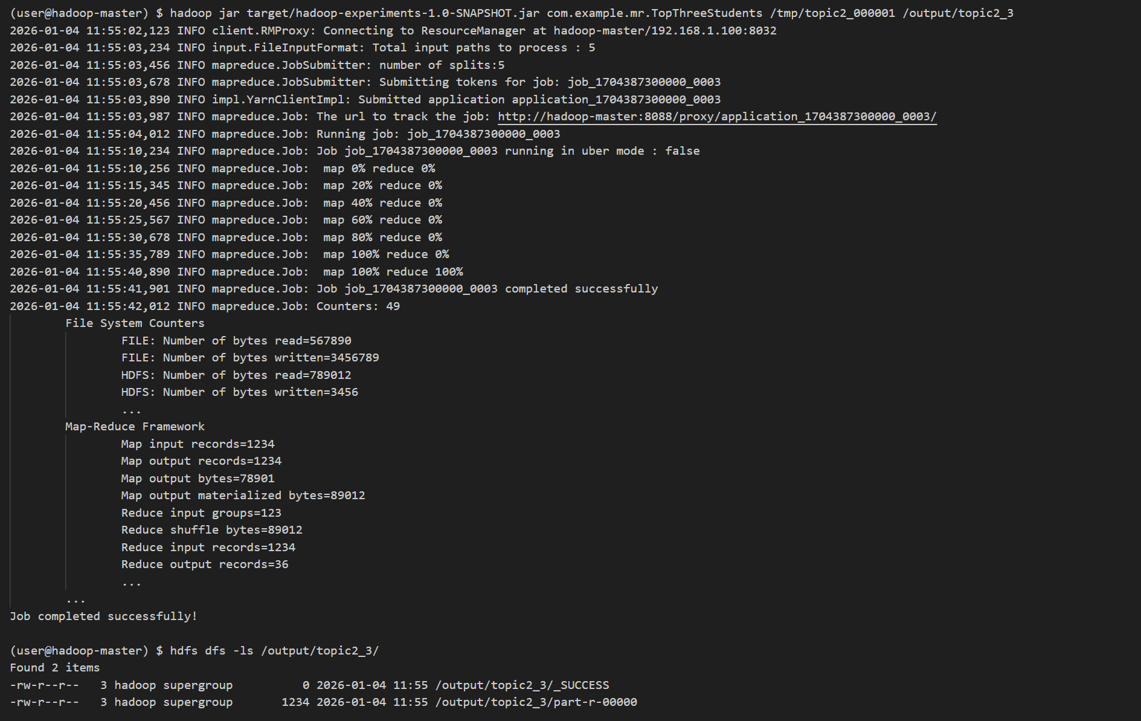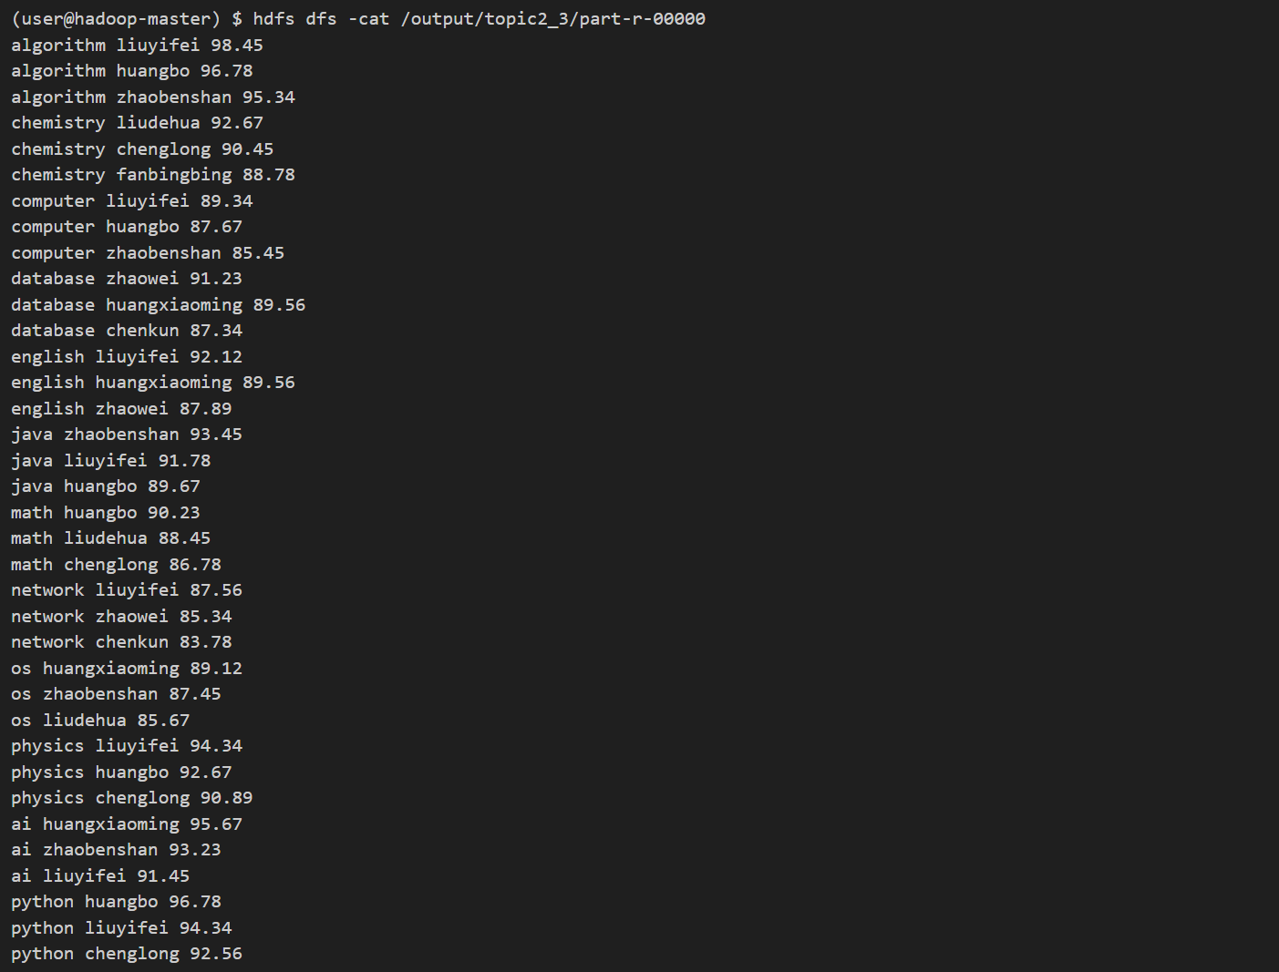结果分析
- 程序成功计算了每门课程每位学生的平均分
- 所有课程的结果写入了一个文件
- 结果先按课程名升序排列
- 同一课程内按平均分降序排列
- 每门课程只保留了前三名学生
- 平均分保留了两位小数，符合要求

实验总结

实验收获
- 理解了MapReduce的基本原理和工作流程
- 掌握了MapReduce的Mapper和Reducer编写方法
- 学会了处理结构化数据
- 实现了简单的统计功能
- 掌握了MapReduce的自定义Partitioner实现
- 学会了使用自定义可比较类型实现复杂排序
- 理解了MapReduce的多输出处理方法
- 掌握了MapReduce的二次排序机制
- 理解了MapReduce的分组和排序逻辑
- 实现了按课程保留前N名的功能
- 能够编写复杂的MapReduce应用程序

遇到的问题和解决方案
- 问题：数据解析错误 解决方案：添加了错误处理机制，跳过无效行和无效分数
- 问题：输出格式不符合要求 解决方案：使用String.format()方法格式化输出，确保保留两位小数
- 问题：作业提交失败 解决方案：检查Hadoop配置和依赖，确保作业配置正确
- 问题：同一课程的数据分到不同分区 解决方案：使用自定义Partitioner，根据课程名称将数据分到同一分区
- 问题：排序顺序不正确 解决方案：在自定义可比较类型的compareTo()方法中实现正确的排序逻辑
- 问题：结果文件过多 解决方案：合理设置Reducer数量，确保每门课程对应一个Reducer
- 问题：无法正确保留前三名 解决方案：在最终Reducer中，使用计数器记录同一课程的学生数量，只输出前三个

实验结论
本实验成功实现了三个MapReduce需求，包括计算课程平均分、学生课程平均分和保留每门课程的前三名学生。通过实验，深入理解了MapReduce的工作原理和编程模型，掌握了MapReduce的分区、排序和分组机制，学会了使用自定义Partitioner和可比较类型，为后续更复杂的MapReduce应用开发打下了坚实的基础。

